We can create a bucket - add data to the bucket , create a subfolder in the bucket and delete data and folder from the bucket using gui .

To make data accessible to users on the internet we have to make bucket public access .

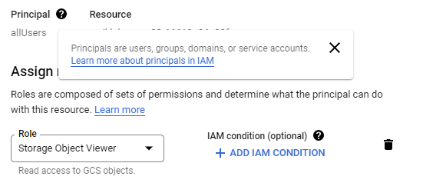

Allow this permission to make public access .



We can share basket objects using url .